ZIMMER + ROHDE
ACOUSTIC PERFORMANCE REPORT

TEST INFORMATION
Test Method: Impedance tube correlation method
Air Gap: 12 cm

ACOUSTIC PERFORMANCE TABLE
Design Name | ISO 11654 Weighted Sound Absorption Coefficient (αw) | ISO 11654 Class | ASTM C423 Sound Absorption Average (SAA) |  | ASTM C423 Noise Reduction Coefficient (NRC)
LILA | 0,60 | Class C |  | 0,59 | 0,65

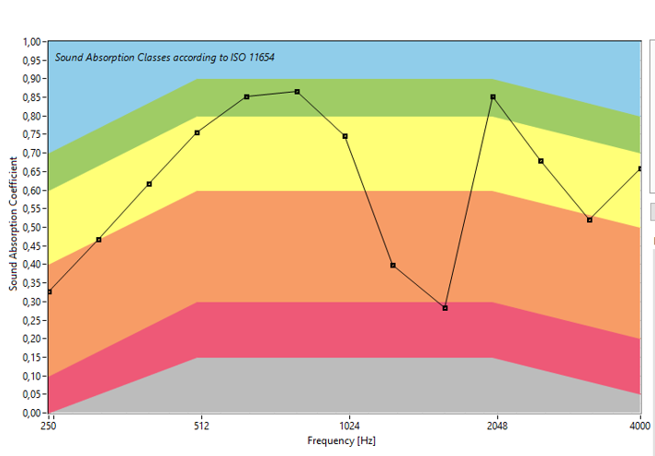

TECHNICAL NOTE
You can find the sound absorption coefficient values ​​of your fabric at specific frequencies from the measurement chart we sent you.
ISO 11654 classification is based on the αw value.
SAA value is the average of 200–2500 Hz.
NRC value is the average of 250, 500, 1000 and 2000 Hz.
Final performance may vary depending on application details.
The values presented in this report (Weighted Sound Absorption Coefficient αw, Class rating according to ISO 11654, Sound Absorption Average – SAA, and Noise Reduction Coefficient – NRC according to ASTM C423) are based on impedance tube measurements.
According to ISO 11654 and ASTM C423, these parameters should be derived from measurements performed in a reverberation chamber in accordance with ISO 354.
The results shown here are intended only for reference and estimation purposes and should not be used in official reports or as ISO 354-compliant certified results.
